**AK State Report Maps – 7.13.20**

The map used for Alaska from <https://www2.census.gov/geo/tiger/TIGER2010/COUNTY/2010/> contains what appears to be extra land far east, outside of Alaska. This specifically came from the county **Aleutians West** having centroid GPS coordinates of (52.680214, -92.487718), which is in Ontario, Canada (north of Minnesota). After further investigation, it appeared clearly that the latitude coordinate (52.68) was accurate, but the longitude coordinate (-92.4877) was clearly wrong. I manually edited the longitude coordinate in the gdf_ct dataframe to -176.487718. Unfortunately, this did not help. I next investigated the Geometry column of the gdf_ct dataframe. There, I found that the most western part of **Aleutians West** contains GPS longitude coordinates that are positive (ie. 179,178, etc). Thus, according to a flat map of Earth, it is located on the other side of the Earth and the map. Anyways, I do not know of a way to fix this. Below each graph is a larger, cropped figure that is easier to see.

**UPDATE 7.21.20**

The version2 of the images on the dropbox folder do not include ‘Aleutians West.’ While this does not drop any dentists for the BOD map, it drops 4 dentists for the MED&CHIP map.

**Original – Accepting Private Insurance Only**

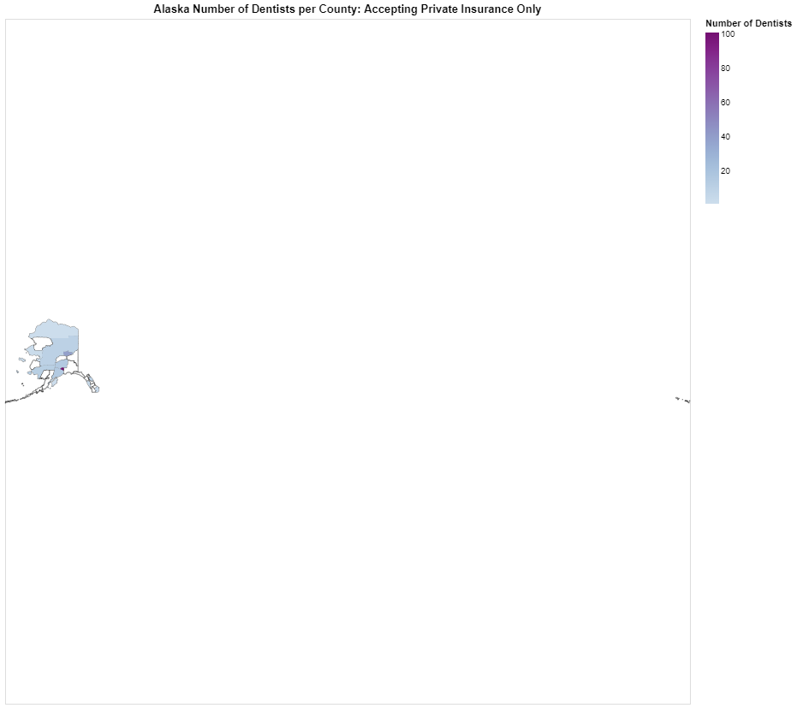

**Cropped - Accepting Private Insurance Only**

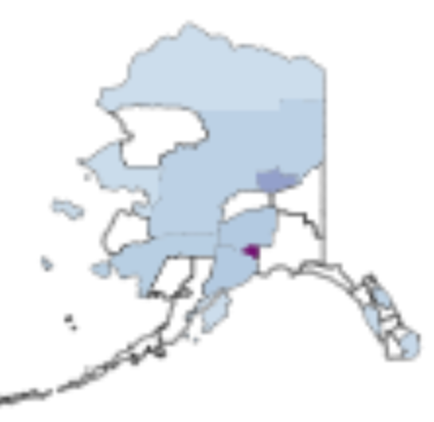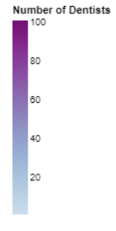

**Original – Accepting Medicaid and CHIP**

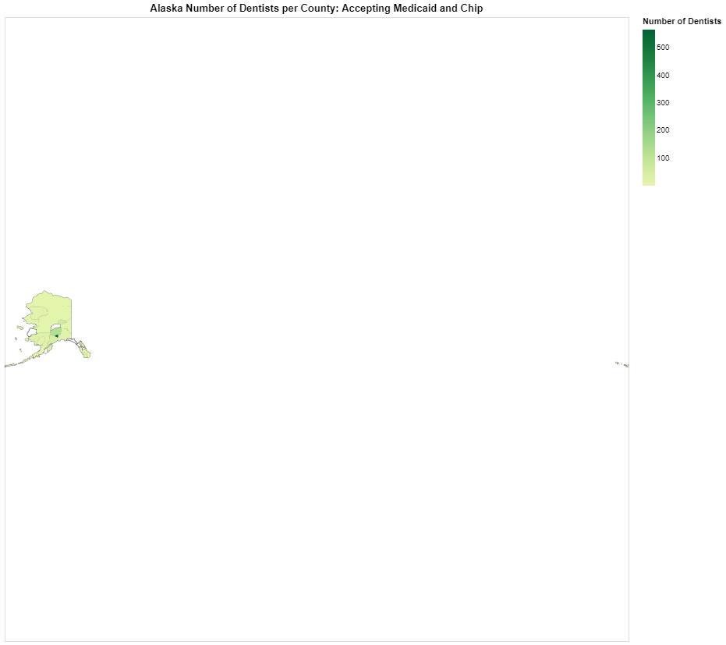

**Cropped – Accepting Medicaid and CHIP**

